

“Spirituality can help people maintain good mental health. It can help them cope with everyday stress and can keep them grounded. Tolerant and inclusive spiritual communities can provide valuable support and friendship. There is some evidence of links between spirituality and improvements in people’s mental health, although researchers do not know exactly how this works”

(<http://www.mentalhealth.org.uk/information/mental-health-a-z/spirituality/>)

People do care. We sometimes struggle to show that we care and how to connect with those affected with mental health problems. Isolation and stigmatisation are some of the issues people with mental health problems will face in their communities. A well-structured pastoral engagement with church members will help in reducing the isolation of its members.

If you feel inspired to work with members of your faith group around the issues of mental health then I would encourage you to sign up for this free 10 week training in pastoral care in mental health.

Directions:

**Buses:**  3, 59, 133, 159 or 415

**Trains:** Brixton Station –

(10 mins walk from Brixton Station)

Nearby parking available after 5.00pm

Training Dates and Times

**Mondays 6 pm – 8.40 pm**

6th January 2020

13th January 2020

20st January 2020

27th January 2020

3rd February 2020

10th February 2020

Half Term

24th February 2020

2nd March 2020

9th March 2020

16th March 2020

All interested persons are invited to attend the

Open Evening & Course Information

Date: Monday 25th November 2019

Time: 5:30pm-6:30pm

Venue:

**332-334 Brixton Road**

**London SW9 7AA**

Book Now! Please complete and return your application form before the Open Evening

&

Confirm if you are attending the Open Evening.

**To book contact Kathleen**

**0203 228 1688**

**Email:** [**kathleen.bertrand-grell@slam.nhs.uk**](mailto:kathleen.bertrand-grell@slam.nhs.uk)

**Thank you**

✂

SPIRITUAL & PASTORAL CARE

TRAINING IN MENTAL HEALTH

Training to provide faith and religious groups/communities with some understanding in mental health.

To develop spiritual and pastoral skills to support people with mental health difficulties living within faith communities.

Suitable for anyone from any faith and religious community, and who are interested in offering pastoral or spiritual care.

Objectives

* Increase awareness in mental health issues
* Understanding the role of religion in mental health
* Develop the ability to reflect on both good and bad practices within faith groups
* Deepening self-knowledge and awareness

Learning Outcomes

At the end of the training participants would be able to demonstrate:

* Some knowledge about pastoral care in mental health
* Personal, social & pastoral competences
* Ability to work under supervision
* To be able to apply knowledge and skill to support people with a mental health problem living in their own communities.

Commitment

Attendance and punctuality are crucial in order to fulfil course aims and objectives.

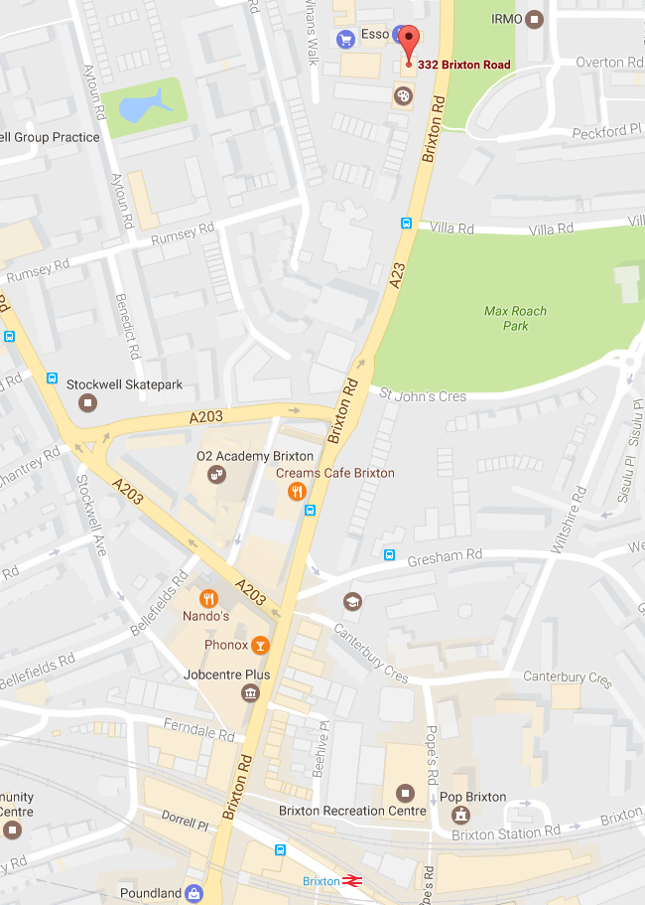

Course MAP

Course Co-ordinator:

Juney Muhammad

Community Development Service Manager

Mental Health Promotion Team

South London & Maudsley NHS

Foundation Trust

Organisers:

SLaM Mental Health Promotional Team

Supported by Chaplaincy Pastoral & Spiritual Care Service

Trainers:

SLaM Mental Health Promotion Team,

Chaplains, Service Users, Improving Access to Psychological Therapies (IAPT) & Psychosis Clinical Academic Group, Oasis, Mental Health Professionals

For further information contact Juney Muhammad on 07791 680262/020 3228 0952 or

Email: [juney.muhammad@slam.nhs.uk](mailto:juney.muhammad@slam.nhs.uk)

SPIRITUAL & PASTORAL CARE TRAINING IN MENTAL HEALTH

If you would like to book a place on the training, please **complete the form** in **BLOCK CAPITAL**

Name: ………………………………………………………..

Address: …..….…………………………………………….

…….........................................................................

Postcode: …………..……………………

Email: ………………………………………………………….

Personal Tel No: ……………………………………….

Name and Address of Faith Group

..............................................................................

……………………………………………………………………..

* I have read and confirm that I am able to attend all 10 sessions of the course between **6thJanuary - 16th March 2020**
* I am able to arrive for the 6 pm start, and stay until 8.40 pm
* I am aware there will be a project to complete during the course, on which I will be expected to do a presentation

Please return completed form now to

to Juney Muhammad the following email: [juney.muhammad@slam.nhs.uk](mailto:juney.muhammad@slam.nhs.uk)

or return slip c/o Juney Muhammad MHPT CR1

Maudsley Hospital Denmark Hill SE5 8AZ

Registration close by Friday 6th December 2019

✂



**Mondays**

**6th January - 16th March 2020**

**6pm – 8.40pm**

**FREE TRAINING**